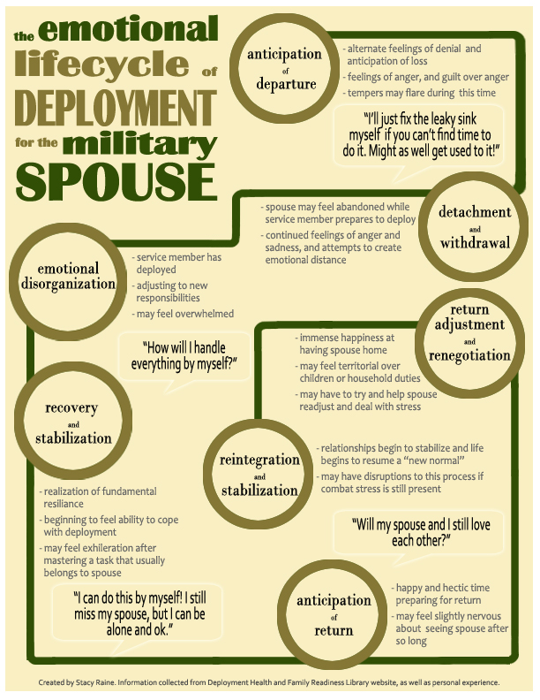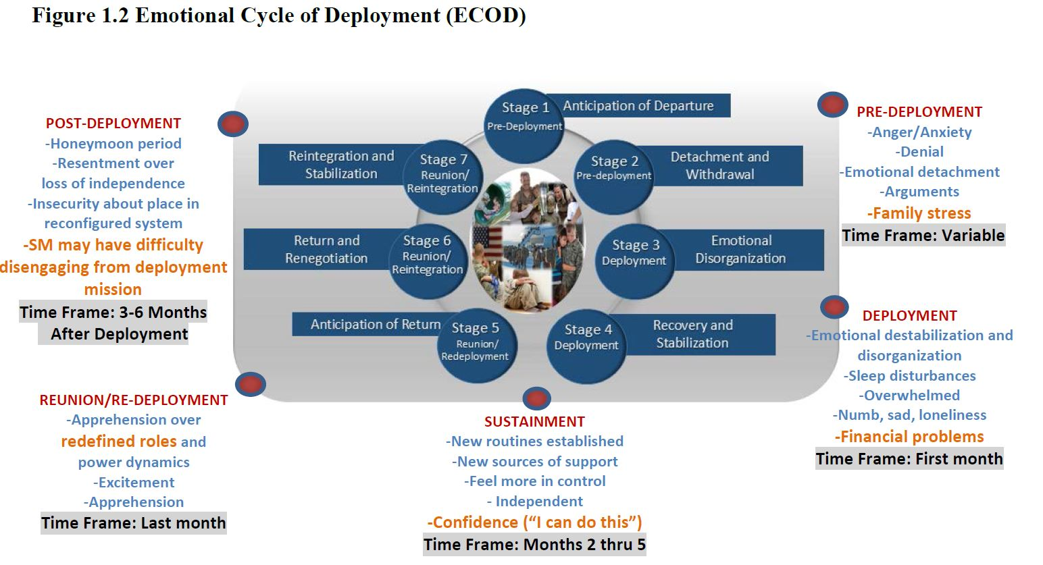
Personal Matters
- Empower Spouse to stay busy/healthy and explain where to go for assistance if needed
- Give spouse or parents the number of 1st Sgt or Commander
- Discuss methods and plans for communication during deployment
- Discuss feelings and include children in discussions
- Mark family calendar with anniversaries, birthdays, graduations, holidays (pack cards)
- Emergency Services explained and located/Arrange for lawn care/snow removal
- Contact school officials (notify teachers/coaches of upcoming deployment)
- Review Life Insurance policies and Beneficiaries
- Discuss the hard topic… Casualty. Does your family know your wishes?
-burial instructions
-cemetery
-death benefits
-guardians

Children:
- Talk about deployment before you leave
- Child may withdraw or be standoffish
- Spend Quality time with each child individually before departure
- Tune into and discuss child’s worries about the deployment
- Leave something that will help them feel connected while you are gone: kissing pillow, pictures on pillow cases, daddy doll.
- Encourage caregiver to establish routine for stability.
- Children will most likely test boundaries and have discipline issues at first.

